Product Archaeology: Auth Review Assistant
Author: Rohan Tejaswi | Date: April 2026 | Prepared for: Machinify — Senior PM, Core Platform Take-Home

1. What Is This Product, Who Uses It, and What's the Architecture?
The Auth Review Assistant is an AI-powered clinical workflow tool that helps insurance payers process prior authorization requests faster using OCR + LLM extraction.
Users
Two user groups are visible from the artifacts:
- Clinical Reviewers (5 total, 3 currently active — Grafana Panel 6): Named reviewers — Maria Torres, James Park, Aisha Williams — filed Issues #7, #14, #22, and #26, revealing a small team experiencing compounding daily friction.
- Clinical Ops Leadership (VP Clinical Ops, Slack Thread #5): Escalated directly on March 28 about auto-approve. Zero response — a business risk as much as a product gap.
Architecture: Claimed vs. Observed
README depicts six components: Rust/Axum API, Kafka CDC ingestor, PostgreSQL, backfill worker, Python OCR+LLM pipeline, and an "ML Scoring Service." The ML Scoring Service does not exist. migrations/007_add_ml_confidence.sql added the column, but Issue #15 confirms no code reads or writes it. The PRD lists it as Phase 2 / NOT STARTED.
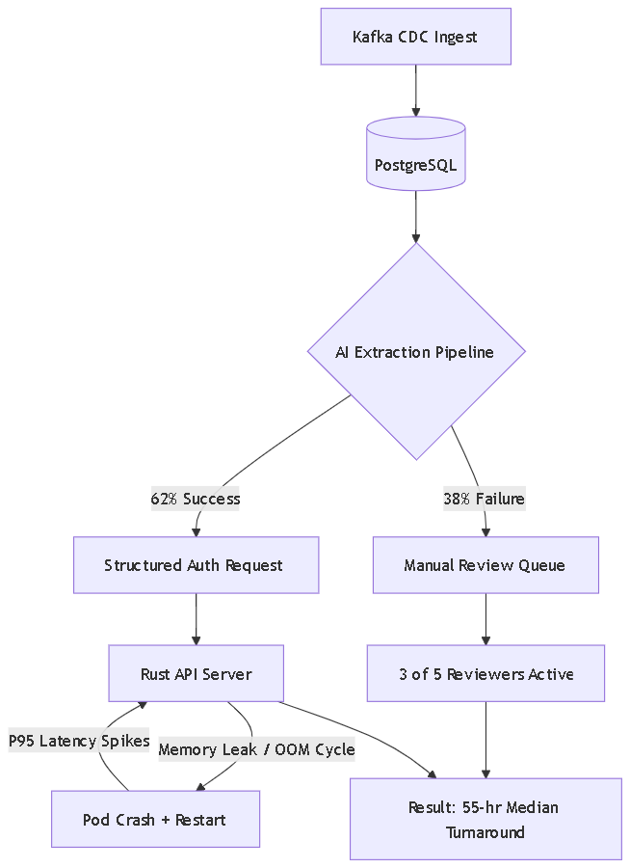

2. What Does the Repo Tell You That the README Doesn't?
Finding 1: The queue is FIFO — urgency is ignored. queries.rs:69–72 orders by ORDER BY submitted_at ASC. This directly causes the problem in Slack Thread #3: reviewers spend 10–15 minutes every morning finding urgent surgical pre-auths buried behind routine lab work. Fixing this is one SQL clause.
Finding 2: PHI encryption is negated by a debug log line. The schema stores patient names encrypted as BYTEA using pgcrypto; queries.rs correctly decrypts in-query. Then at queries.rs:42:
log::debug!("Fetched auth request for patient: {} {}",
request.patient_first_name, request.patient_last_name);
At RUST_LOG=info this isn't actively leaking — but the API pod OOM-crashes every ~48 hours (Issue #10), and PR #54 to fix it sits unreviewed.
Finding 3: Kubernetes resource limits are dangerously tight. values.yaml shows 64Mi request / 128Mi limit — directly explaining the OOM restart cycle (Grafana Panel 4: P95 spikes to 6–8s correlating with restarts; Slack Thread #1). Issue #12 requested an HPA and resource bump — unassigned.
Finding 4: Pipeline CI has been disabled since December. .github/workflows/pipeline-test.yaml.disabled — Jordan confirmed in Slack Thread #2: "the OCR mock was flaking so I disabled it… that was 4 months ago." Issue #16 (wrong LLM model running due to config.py vs config.yaml mismatch) was a direct consequence — batch_runner.py imports pipeline.config (Python defaults), not the YAML.
Finding 5: Analytics endpoints will crash if called. The turnaround endpoint is a todo!() macro (analytics.rs:20–29) — it panics in production. If the VP navigates there, it crashes the API pod.

3. What's Working and What's Broken?
Working
- Core workflow is live: reviewers process cases daily at 62% AI extraction rate (Grafana Panel 3). Phase 1 PRD items confirmed shipped.
- CDC ingestor is functionally stable; duplicates handled via idempotent upserts (Issue #4).

Broken or Dangerously Degraded
Problem | Evidence
Turnaround worsening: 48→55 hrs (Critical) | Grafana P2; KR1
Extraction plateaued 62%, 6 weeks (High) | Grafana P3; KR2
PHI plaintext in debug logs (High) | queries.rs:42; PR #54 unreviewed
API pod OOM every ~48hrs (High) | Grafana P4; Issue #10; values.yaml
No urgency sort in queue (High) | queries.rs:69-72; Issues #26, #5
No LLM retry logic (High) | Issue #11
Analytics endpoints crash if called (Medium) | analytics.rs:20-29; Issue #19
PR #47 approved, unmerged 45 days (Medium) | PULL-REQUESTS.md
CI disabled since December (Medium) | pipeline-test.yaml.disabled
Config split with contradictions (Medium) | Issue #16; config.py vs config.yaml

4. The Single Most Important Problem: The Throughput Ceiling
The system is approaching a throughput crisis:
- Volume: ~200/day → ~340/day (+70% in 90 days, accelerating)
- Active reviewers: 5 → 3 (−40% in same window)
- AI extraction: flat at 62% for 6 weeks
- Result: median turnaround 48→55 hrs, moving away from 28-hour target

With 340 requests/day and 38% requiring manual review, that's ~130 manual cases/day across 3 reviewers — ~43 each. At 3%/week volume growth with flat capacity, 100-hour turnaround is reachable within 6–8 weeks.
The extraction ceiling is not a research problem — it's three known, unactioned fixes: PR #47 (approved, unmerged), Issue #11 (LLM retry, ~1 day), Issue #6 (PDF rotation, known solution). Fixing all three likely moves extraction from 62% to ~82–85%, unlocking auto-approve — the volume reduction the VP has been asking for.

5. What's Missing to Validate This Diagnosis
- Why did 2 of 5 reviewers go inactive in mid-February? The drop is real (Grafana Panel 6); the cause is not in any artifact.
- What share of current backlog matches auto-approve CPT codes? Distribution data is absent; ROI depends on routine-code prevalence.
- Has legal reviewed auto-approve for state-specific prior auth regulations? The PRD flagged this. No evidence a review happened.
- Has `RUST_LOG=debug` ever been set in production during incident response? The PHI log line exists; whether it has been activated is unknown.

